**The Use of Dome Shaped Osteotomy and Plating in Correction of Genu Varum**

Mahmoud T. Ibrahim*, Hany A. Basiony, Sheref A. Eltraigy, Mahmoud S. Abouzied

Orthopedic Department, Faculty of Medicine, Benha University, Benha, Egypt

E-Mail:

Abstract

**Background:** Genu varum deformities of the leg are often associated with internal tibial torsion and can occur unilaterally, bilaterally or as part of a windswept deformity. Amongst the causes for a genu varum deformity are physiological bowlegs, Blount disease, rickets, infections, traumatic growth plate injuries, skeletal dysplasias and neoplasms. Common causes for a genu varum deformity in Africa are Blount disease and rickets. However, little is known about the exact incidence of these diseases. One report estimates the prevalence of infantile Blount disease in the Caribbean at 1/1200 live births, with bilateral involvement in 37–62%. Rickets remains a significant health problem in developing countries, with the prevalence in different African countries ranging from 3% to 42%. A population study in The Gambia found the clinical criteria of rickets in 3.3% of children under the age of 18, while only 0.6% showed radiographic signs of rickets. In this study, bilateral bow leg deformity was the most common deformity (53%), followed by knock knee deformity (47%). **Objective:** This review article aims to to evaluate and compare the functional, clinical and radiological outcome of dome osteotomy and fixation by T or L plate used in genu varum.

**Conclusions:** Automatic knee osteotomy planning analyzes the metaphyseal deformity of both the tibia and the femur, and the software suggests the optimal procedure with the degree of openness to obtain the desired mechanical axis without creating excessive joint line obliquity. An osteotomy of the proximal tibia using a prescribed technique linked to a proprietary implant achieves good results only if performed within a certain range of deformity values. Pronounced varus deformities require a fundamentally different approach. Surgeons undertaking corrective proximal tibial osteotomies for genu varum need to perform a comprehensive analysis of the deformity to allow for appropriate selection of patients. This will enable a consideration of the size and other characteristics of the deformity that will reduce the technical complications that may arise if the correction was performed using the recommended technique linked to a proprietary implant.

**Keywords:** Dome Shaped Osteotomy; Plating; Genu Varum.

1. Introduction

Angular deformities of the lower limbs are common during childhood. In most cases this represents a variation in the normal growth pattern and is an entirely benign condition. Presence of symmetrical deformities and absence of symptoms, joint stiffness, systemic disorders or syndromes indicates a benign condition with excellent long-term outcome. In contrast, deformities which are asymmetrical and associated with pain, joint stiffness, systemic disorders or syndromes may indicate a serious underlying cause and require treatment **(Espandar et al., 2010)**.

A type of knee joint deformity known as genu varum is characterized by a shift in the limbs' natural alignment such that the knee joints' centers are located outside of the limbs' mechanical axes. The patient has this deformity, which causes their knees to appear apart when they are standing, giving the limbs the appearance of parentheses **(van Drongelen et al., 2020)**.

High tibial osteotomy (HTO) is often referred to as proximal tibial osteotomy and is a frequently practiced surgical procedure for painful knees with varus malalignment due to OA and overload in the medial compartment. Initially, HTO was introduced by Jackson et al in 1961, and thereafter Sir Robert Jones mentioned the use of tibial osteotomies to correct genu varum due to rickets as documented by Wardle in 1962 **(Nikose et al., 2020)**.

However, Coventry popularized the technique in 1985. The primary objective of HTO is pain relief in OA in order to delay or avoid the need for knee replacement by unloading the medial joint compartment and realigning the mechanical axis of the lower limb thus slowing the degeneration. Moreover, HTO minimizes knee pain by shifting the loads during weight-bearing to the relatively unaffected lateral compartment after correction in varus knees. There are different HTO techniques such as open-medial wedge osteotomy, closed lateral wedge osteotomy, progressive callus distraction and dome osteotomy **(Lee and Byun, 2012)**.

Although there are different treatment methods for the correction of genu varum, detailed assessments before surgery play an important role in the selection of the appropriate treatment and the treatment success **(Tabatabaei et al., 2017)**.

This review aimed to evaluate the functional, clinical and radiological outcome of dome osteotomy and fixation by T or L plate used in genu varum.

1. Anatomy of knee joint:

The knee joint fascinates everyone with its complexity. It has the femur and tibia articulating with each other and the patella which glides over femur **(Vaienti et al., 2017)**.

* Articulation:

Above are the rounded condyles of the femur; below are the condyles of the tibia and their cartilaginous menisci; in front is the articulation between the lower end of the femur and the patella. The articular surfaces are covered with hyaline cartilage. Note that the articular surfaces of the medial and lateral condyles of the tibia are often referred to clinically as the medial and lateral tibial plateaus **(Cianferotti et al., 2023)**.

* Type:

The joint between the femur and tibia is a synovial joint of the hinge variety, but some degree of rotatory movement is possible. The joint between the patella and femur is a synovial joint of the plane gliding variety **(Hadeed et al., 2018)**.

**Capsule:** The capsule is attached to the margins of the articular surfaces and surrounds the sides and posterior aspect of the joint. On the anterior aspect of the joint, the capsule is absent, permitting the synovial membrane to pouch upward beneath the quadriceps tendon, forming the suprapatellar bursa. On each side of the patella, the capsule is strengthened by expansions from the tendons of vastus lateralis and medialis. Behind the joint, the capsule is strengthened by an expansion of the semimembranous muscle called the oblique popliteal ligament. An opening in the capsule behind the lateral tibial condyle permits the tendon of the popliteus to emerge **(Tsutsumi et al., 2023)**.

Tibia: The tibia is the large weight-bearing medial bone of the leg. It articulates with the condyles of the femur in the knee.The lateral condyle possesses on its lateral aspect a small circular articular facet for the head of the fibula. The semimembranosus muscle inserts posteriorly in medial condyle. The tendons of Sartorius, Gracilis and Semitendinosus insert in the proximal shaft in medial aspect and the pes anserinus bursa is present between them. At the junction of the anterior border with the upper end of the tibia is the tuberosity, which receives the attachment of the ligamentum patellae. This tibial tuberosity with its ligamentum patellae is very important for extension of the knee **(Puzzitiello et al., 2018)**.

* Anatomy of proximal tibia

The tibia is one of two bones that comprise the leg. As the weight-bearing bone, it is significantly larger and stronger than its counterpart, the fibula. The tibia forms the knee joint proximally with the femur and forms the ankle joint distally with the fibula and talus. The tibia runs medial to the fibula from just below the knee joint to the ankle joint and is connected to the fibula by the interosseous membrane **(Bourne et al., 2024)**.

The proximal end of the tibia features several important landmarks which function as sites of muscle attachment and articular surfaces: two tibial condyles (medial and lateral) separated by intercondylar areas (anterior and posterior) which is where the anterior collateral ligament, posterior collateral ligament, and menisci all have attachments. The superior surface of the medial condyle is round in shape and somewhat concave, so it fits perfectly into a joint with the medial condyle of the femur. The medial meniscus is sandwiched between the tibia and femur in this joint with attachments to all margins except for the lateral margin. Instead, the lateral margin extends to the medial intercondylar tubercle **(Bourne et al., 2024)**.

On the other hand, the superior surface of the lateral condyle is pretty much a mirror image of the medial condyle. It is round in shape, somewhat convex, and articulates with the lateral condyle of the femur. The lateral meniscus attaches to all of its margins except for the medial margin. The medial margin extends to the lateral intercondylar tubercle. The lateral and medial menisci are the pads of fibrocartilage inserted to ease the pressure that is transmitted from the femur to the condyles **(Lee)**.

The superior surfaces of the condyles are flattened and together they form the superior articular surface called the tibial plateau. Here, the tibial condyles articulate with the femoral condyles within the knee joint. The articular surfaces are separated by two small prominences, the medial and lateral intercondylar tubercles. These tubercles form the intercondylar eminence, which is bordered by the anterior and posterior intercondylar areas **(Samelis et al., 2023)**.

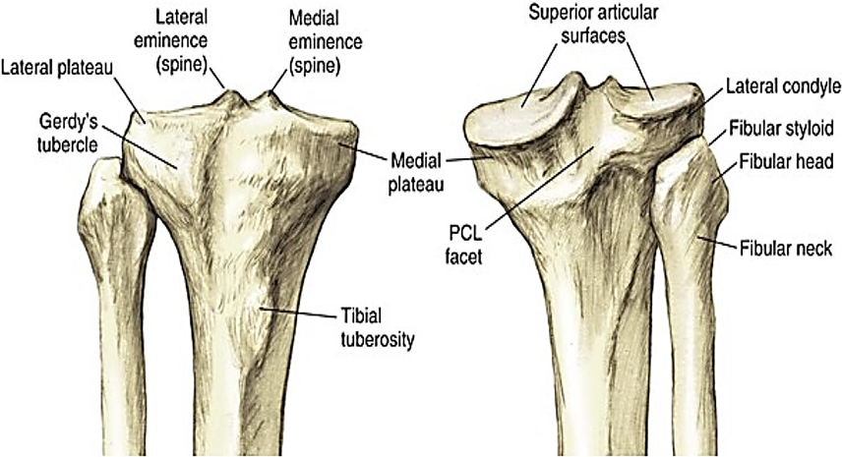

Figure 1: Proximal end of tibia adopted by Bourne et al., (Bourne et al., 2024)

1. Biomechanics

The mechanical axis of the lower limb is determined on the full- length AP standing radiograph. The axis passes through the center point of the hip joint (center of the femoral bead) and through the center point of the ankle joint (midpoint of the tibial plafond). The mechanical axis should pass just medial to the center point of the knee joint. The lateral or medial mechanical axis deviation (MAD) from the center of the joint is measured in millimeters (mm). The anatomic axis of the lower limb is evaluated on the full- length AP radiograph by measuring the anatomic tibiofemoral angle, i.e., the upper acute angle formed by the anatomic axes of the femur and tibia **(Marques Luís and Varatojo, 2021)**.

* Biomechanics of tibia

As the second-largest bone in the body, the tibia's main function in the leg is to bear weight with the medial aspect of the tibia bearing the majority of the weight load. It also serves as the origin or insertion site for 11 muscles; these allow for extension and flexion at the knee joint and dorsiflexion and plantarflexion at the ankle joint **(Guerra-Pinto et al., 2018)**.

The knee joint is basically a [hinge joint](https://www.physio-pedia.com/Joint_Classification) with the main movement of flexion-extension. However, the radius and the length of the articular surface of the [femu](https://www.physio-pedia.com/Femur)r and [tibia](https://www.physio-pedia.com/Tibia) differ at the knee joint. Articular surface of medial condyle of femur is greater than the articular surface of lateral condyle. As a result, a complex movement (includes "sliding") occurs during the last 30 degrees of knee extension, in addition to rolling between the two bones this allows the knee joint to move smoothly. At terminal extension, the knee joint is slightly hyperextended and stabilized with the tightening of the [cruciate](https://www.physio-pedia.com/Anterior_Cruciate_Ligament_(ACL)) and [collateral](https://www.physio-pedia.com/Medial_Collateral_Ligament_Injury_of_the_Knee) ligaments **(Wang et al., 2021)**.

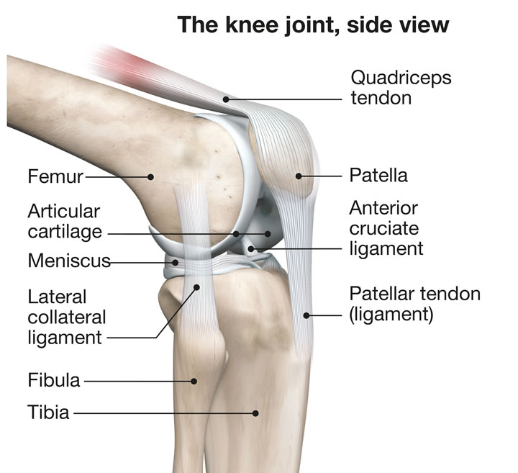

Figure 2: Knee joint adopted by Standring, (Pathria et al., 2016).

As the length of the medial femoral condyle is longer than the length of the lateral condyle, the tibia rotates externally about 15° on the femur during the last 20° of extension. This kinematic phenomenon is well known, and it is called the screw-home movement **(Kim et al., 2015)**.

The shape of the condyles are not what brings about the movements. Tibial-on-femoral rotation occurs in an open chain exercise like in the leg extension machine (tibia externally rotates). Femoral-on-tibial rotation, as in a closed chain exercise like the squat (femur internally rotate). During knee extension, tibia rolls anteriorly, elongating the PCL and the PCL’s pull-on tibia, causes it to glide anteriorly. During knee flexion tibia rolls posteriorly, elongating the ACL and it is the ACL’s pull on tibia, that causes it to glide posteriorly. [Popliteus](https://www.physio-pedia.com/Popliteus_Muscle) - unlocks knee with open chain motions. [Hip external rotation](https://www.physio-pedia.com/Gluteus_Medius) - unlocks knee with closed chain motions **(Javidan et al., 2021)**.

The "screw-home" mechanism is considered to be a key element to knee stability for standing upright. The tibia rotates internally during the swing phase and externally during the stance phase. External rotation occurs during the terminal degrees of knee extension and results in tightening of both cruciate ligaments, which locks the knee. The tibia is then in the position of maximal stability with respect to the femur. Last 30 degrees of extension causes a medial rotation of  femur on tibia will keep joint in closed  packed position. The knee is unlocked by lateral rotation of femur. In open Kinematic chain Tibia laterally rotates on Femur during last 5 degrees of extension to produce locking. Unlocking by medial rotation. Tibial shear force is a major determinant of the force transmitted to the cruciate ligaments of the knee. This force derives from three main sources: an external load arising from the presence of the ground reaction force; knee muscle activity; and the contact force acting between the femur and tibia **(Pathria et al., 2016)**.

The tibiofemoral contact force induces an anterior directed shear force on the tibia, caused by the posterior slope of the tibial plateau in the sagittal plane. This anterior shear force can be substantial during daily physical activity. During walking, for example, the shear force created by the tibiofemoral contact force is as large as that produced by the ground reaction force and the knee muscles **(Shimokochi et al., 2016)**.

* Function of the Knee:

The knee is complemented with a selection of ligaments including the anterior and posterior cruciates, and the medial and lateral collateral ligaments. These serve to strengthen the knee structure as well as place restraints on the range of movements through which it can travel. Due to its location within the human skeleton, and the fact humans are bipeds, the knee joint is constantly exposed to varying forces which it must cushion and absorb to prevent the formation of pathological stresses. To cushion joint load, the articular surfaces are covered in cartilage, and the knee is equipped with the medial and lateral menisci which sit between the two articular surfaces of the femur and tibia **(Niu et al., 2017)**.

Many muscles have insertions around the knee joint. Although some of these do not necessarily take part in gross knee movement, they play a crucial role in dynamic knee stability. The quadriceps muscle group sits above the patella and comprises the rectus femoris, vastus lateralis, intermedius and medialis. The quadriceps muscle group interacts with the patella via the patella ligament to extend the knee and maintain dynamic knee stability **(Gitajn and Rodriguez, 2011)**.

* Physiological or Mechanical axis of the leg:

The anatomical axis of the femur and tibia correspond to the diaphyseal midline of these long bones. The mechanical axis of the femur runs from the center of the femoral head to the center of the knee joint. The mechanical axis of the leg (Mikulicz line) is the connecting line between the center of the femoral head and the center of the ankle joint. This line runs on an average 4 (± 2) mm medial to the center of the knee joint. If the mechanical axis runs lateral or medial to this point, this indicates either a valgus or a varus deformity **(Marques Luís and Varatojo, 2021)**.

1. Pathological biomechanics

The loading in the knee joint is the largest of all joints. Repetitive and cyclic nature of walking associates it with osteoarthritis knee Mechanical overload causes micro damage in the subchondral bone leading to bone remodeling. This remodeling increases the bone density, thereby decreasing its efficacy as a shock absorber. Thus, the joint cartilage suffers increasing dynamic stresses and it gets destroyed **(Primorac et al., 2020)**.

The distance between a deformity and a compensating joint affects the deviation of the mechanical axis, which in turn affects joint contact pressures. In the coronal (frontal) plane the compensating joints are the hip and subtalar joint. The knee cannot compensate in this plane and therefore deformities of the distal femur or proximal tibia result in marked axis deviation and increase in knee joint contact pressures. Deformity situated near the hip or ankle joints does not result in a large axis deviation but significantly changes the inclination of those joints **(Kow et al., 2022)**.

This leads to a decreased contact area and secondary increases in contact pressure. Thus deformity near the knee leads to abnormal knee contact pressures and deformity near the ankle leads to abnormal ankle contact pressures. Leg length discrepancy will lead to compensatory mechanisms to limit the vertical excursion of the body while walking in an attempt to limit energy expenditure. These mechanisms include pelvic tilt, knee flexion,and ankle equinus ,and depend on adequate range of motion and strength at each joint. Low back pain and patello-femoral symptoms may result **(Pagliazzi et al., 2022)**.

* Consequences of the lower limb deformities:

In the presence of tibial or femoral deviations in the frontal plane, forces can no longer be transferred uniformly at the knee joint. Instead, nonphysiological load distribution with mechanical stress occurs in the medial or lateral compartment. The mechanical overload of a joint compartment correlates with cartilage damage and promotes the development of degenerative joint disease or accelerates its progress. Deformities of the lower extremity are regarded as so-called prearthritic deformities **(Patel et al., 2022)**.

Proximal tibial osteotomies have a substantial effect on the load balance and the distribution of pressure at the knee joint. Open wedge and closed wedge osteotomies are established procedures for the restoration of the physiological axis and the treatment of varus and valgus to the knee joint **(Murray et al., 2021)**.

* Genu varum:

In genu varum the axis of femur and tibial diaphysis (aFTA) is marked and the lateral angle between them is calculated to be greater than 173˚ -175˚.The weight bearing line from the center of the femoral head to the midpoint of the upper ankle joint runs more than 4 (± 2) mm medial to the center of the knee joint, ie, in the case of a significant varus malalignment, the deviation of the mechanical axis (MAD) from the center of the knee joint will be more than 15mm medially. The distance between the femoral condyles (intercondylar distance) is increased **(Zahn et al., 2019)**.

1. Management

* Clinical Examination:

Patient history and clinical examination are the baseline of any preoperative work up for osteotomies around the knee. History of trauma or previous surgery, and professional activity and sports, are of special interest. The expected patient activity level is to be considered. Contraindications such as nicotine abuse, which often leads to delayed consolidation of the osteotomy, overweight, rheumatoid arthritis, and patient age over 60-70 years, where knee arthroplasty leads to better results, must be ruled out. Nevertheless, consideration of biological age should take priority over chronological age **(Zampogna et al., 2019)**.

Clinical examination includes evaluation of soft tissue and skin as well as vascular and neurological status of the lower extremity. Systemic or local infection should be ruled out **(Gasparis et al., 2020)**.

The range of motion of the knee should be at least 120˚ of flexion and not more than 20˚ extension deficit are mandatory. Anteroposterior and mediolateral ligamentous stability should be examined, and the leg length must be inspected. The alignment of the lower extremity is evaluated under full weight bearing and in the supine position. If the medial compartment is involved, movement under varus stress is painful, whereas valgus stress should reduce pain **(Martay et al., 2018)**.

* Radiographic views:

For preoperative assessment of the anatomy and the leg axis radiography of the knee joint in three planes (AP, lateral view, patella tangential view) and a weight- bearing x-ray of the entire lower limb are necessary. The weight-bearing x-ray of the leg is essential to assess the correct indication and for the planning of any osteotomy around the knee **(Khalifa et al., 2021)**.

The examination is performed in AP projection with a horizontally focused x- ray beam with the patient weight bearing on both legs. Malrotation must be avoided by aligning the patella to the front in the center of the femoral condyles. Weight bearing x-rays with the knee in a flexion of 45˚ (so called Rosenberg view) may give information about the degree of changes and the joint collapse, respectively the joint space narrowing of the affected compartment, but are not absolutely necessary **(Pinsornsak et al., 2016)**.

* Treatment of genu varum:
* **Conservative treatment:**

For mild cases that don’t cause much pain, physical therapy and weight training can help to strengthen the muscles surrounding bones. However, they won’t straighten the bones.

* **Surgically:**

The most common type of surgery used to treat varus knee without significant osteoarthritis, particularly in younger adult patients, is a high tibial osteotomy. This procedure realigns the tibia by cutting into the bone and reshaping it. There are various HTO techniques including closing wedge osteotomy, opening wedge osteotomy, dome osteotomy, progressive callus distraction, and chevron osteotomy **(Peng et al., 2021)**.

**Osteotomies around the Knee**: Osteotomies around the knee are an accepted method for the treatment of unicompartmental OA with associated varus or valgus deformity. Osteotomies have been carried out since the nineteenth century. Osteotomies around the knee alter the weightbearing axis of the lower extremity. The aim is to unload the damaged compartment and to transfer the weight load from the affected areas by slightly overcorrecting into a valgus or varus axis to reduce pain, slow the degenerative process, and delay joint replacement **(Martay et al., 2018)**.

After detailed examination of the patient, correct planning is essential for successful osteotomy. A variety of approaches can be used to achieve a good result **(Lee and Byun, 2012)**.

**Level of osteotomy**: The osteotomy should be performed at the apex of the deformity. This will result in an optimal correction. Performed an osteotomy at a different level will not restore the physiological axes but create a new deformity. The metaphysis of a long bone is the region of best healing capacity. Bone healing is significantly decreased at the diaphyseal bone **(Gao et al., 2019)**.

Open wedge osteotomies are generally easier and more precise to perform than closed-wedge osteotomies. Furthermore, the opening procedure allows for intraoperative tuning by adjusting the opening with a spreader. In most cases bone grafting is unnecessary when angular stable implants are used. Restoring or preserving the horizontal joint line (midjoint line) is mandatory for achieving a good result **(Kızılgöz et al., 2019)**.

**Planning method by Miniaci**: Once the localisation and kind of osteotomy is defined the preoperative drawing can be done. This can be done either on the weight bearing x-ray of the leg or at a digital workstation. Several methods of planning an osteotomy are described in the literature. Based on a study by Fugisawa et al and the planning method described by Miniaci, the authors have developed a technique to define the correction angle **(Krettek and Edwards, 2023)**.

Miniaci et al 1989 used the weight bearing line (WBL) to determine the correction angle. The first line is the WBL for correction extending from the center of the hip through 60-70% of the tibial plateau width past the ankle. The second line passes from the hinge point to the center of ankle **(Jiang et al., 2022)**.

The third line connects the osteotomy hinge point with the arc intersection of first one. The angle formed by second and third lines is the planned correction angle (x) **(Huang et al., 2014)**.

A partial deformity analysis without considering the femoral or intra-articular deformity may lead to overcorrection or excessive joint line obliquity. Preoperative planning using the Miniaci method with manual or semiautomated digital measures may help to prevent these types of errors. Technique Description Landmarks are used at the proximal femoral side, distal condyles, proximal tibial plateau, and talus borders to define angles automatically on PeekMed software. Fujisawa point is determined to be 50% of the length of the proximal tibia, and Miniaci method is performed after defining the weightbearing line. The method can be performed manually or semiautomatically with the software **(Micicoi et al., 2021)**.

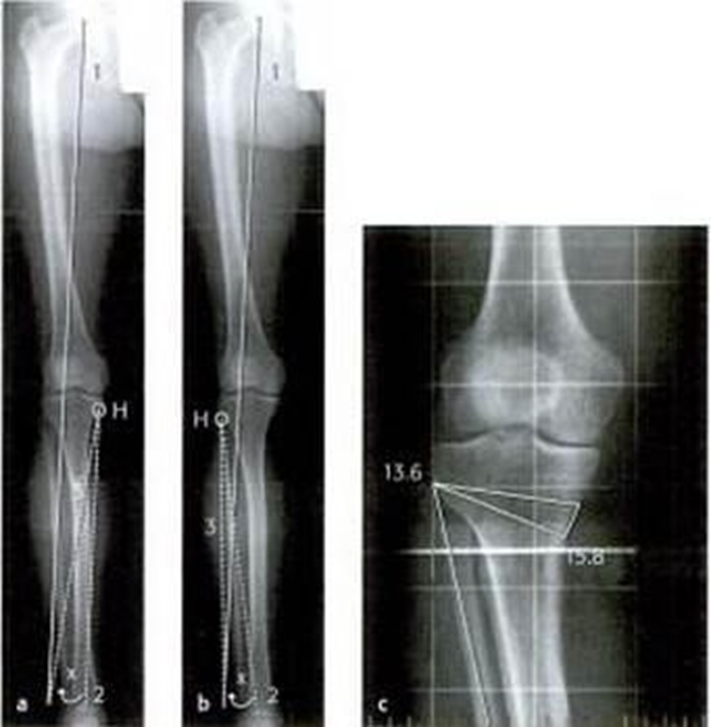

Figure 3: Miniaci method (AO – Osteotomies around the knee)

Proximal tibial osteotomy: High tibial osteotomy is an accepted procedure for treating unicompartmental osteoarthritis of the knee. Most reports have shown approximately 80% satisfactory results 5 years after osteotomy. Varus or valgus deformities are fairly common and cause an abnormal distribution of the weight bearing stresses within the joint. The most common deformity in osteoarthritic knee patients is a varus position, which causes stresses to be concentrated medially, accelerating degenerative changes in the medial part of the joint. In osteotomy the joint compartment which is involved is unloaded and the alignment corrected to distribute stress equally on the knee **(Wong Wei Kang et al., 2021)**.

Some authors have reported arthroscopic evidence of fibrocartilaginous repair. Kanamiya et al. found that only three of the 58 knees showed no signs of repair, and 55% of patients had partial or complete coverage of eburnated lesions with fibrocartilage **(Kanamiya et al., 2002)**.

* Dome Shaped Osteotomy

The approach to the fibula was a standard postero-lateral approach at the level of the junction of proximal and middle thirds of the fibula, taking precaution to prevent injury to the peroneal nerve. An anteriomedial longitudinal incision was made over the proximal tibia. The periosteum of the tibia was elevated, and retractors were placed posteriomedially and posteriolaterally to protect the soft tissues **(Liu et al., 2021)**.

Level of osteotomy was determined just distal to the tibial tuberosity in the metaphysel bone. Osteotomy was done by share small osteotome after drilling its crescent plane. Through dome shaped osteotomy, angular and rotational correction was obtained and over correction of 5° of valgus was achieved intra operative using knee joint line measurement. The periosteum over the osteotomy was re approximated, skin and subcutaneous tissue was closed **(Igarashi et al., 2020)**.

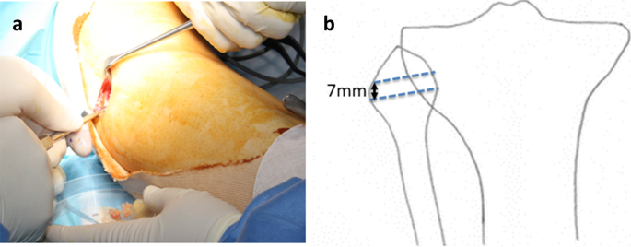

Figure 4: Dome Shaped Osteotomy: a) A skin incision of approximately 3 cm is made anterior to the fibular neck and subcutaneously expanded to expose the fibular neck. B) A distal 15 mm segment of the fibular head was excised with 7 mm height. (Takahashi et al., 2023)

* Complications:

Over and undercorrection of the mechanical axis as a result of inadequate preoperative planning and insufficient intraoperative assessment of the axis. Damage to the bone surface due to excessive pressure, hematoma, postoperative soft-tissue swelling and lymph edema, deep crural thrombosis and /or pulmonary embolism, compartment syndrome, superficial and deep infections, delayed consolidation of the osteotomy gap **(Elyasi et al., 2021)**.

1. Conclusions:

An osteotomy of the proximal tibia using a prescribed technique linked to a proprietary implant achieves good results only if performed within a certain range of deformity values. Pronounced varus deformities require a fundamentally different approach. Surgeons undertaking corrective proximal tibial osteotomies for genu varum need to perform a comprehensive analysis of the deformity to allow for appropriate selection of patients. This will enable a consideration of the size and other characteristics of the deformity that will reduce the technical complications that may arise if the correction was performed using the recommended technique linked to a proprietary implant.

1. References

Bourne, M., Sinkler, M. A. & Murphy, P. B. 2024. Anatomy, Bony Pelvis and Lower Limb: Tibia. *StatPearls.* Treasure Island (FL) ineligible companies. Disclosure: Margaret Sinkler declares no relevant financial relationships with ineligible companies. Disclosure: Patrick Murphy declares no relevant financial relationships with ineligible companies.: StatPearls Publishing

Copyright © 2024, StatPearls Publishing LLC.

**Cianferotti, L., Cipriani, C., Corbetta, S., Corona, G., Defeudis, G., Lania, A. G., Messina, C., Napoli, N. & Mazziotti, G. 2023.** Bone quality in endocrine diseases: determinants and clinical relevance. *J Endocrinol Invest,* 46**,** 1283-1304.

**Elyasi, E., Cavalié, G., Perrier, A., Graff, W. & Payan, Y. 2021.** A Systematic Review on Selected Complications of Open-Wedge High Tibial Osteotomy from Clinical and Biomechanical Perspectives. *Appl Bionics Biomech,* 2021**,** 9974666.

**Espandar, R., Mortazavi, S. M. & Baghdadi, T. 2010.** Angular deformities of the lower limb in children. *Asian J Sports Med,* 1**,** 46-53.

**Gao, L., Madry, H., Chugaev, D. V., Denti, M., Frolov, A., Burtsev, M., Magnitskaya, N., Mukhanov, V., Neyret, P., Solomin, L. N., Sorokin, E., Staubli, A. E., Stone, K. R., Vilenskiy, V., Zayats, V., Pape, D. & Korolev, A. 2019.** Advances in modern osteotomies around the knee : Report on the Association of Sports Traumatology, Arthroscopy, Orthopaedic surgery, Rehabilitation (ASTAOR) Moscow International Osteotomy Congress 2017. *J Exp Orthop,* 6**,** 9.

**Gasparis, A. P., Kim, P. S., Dean, S. M., Khilnani, N. M. & Labropoulos, N. 2020.** Diagnostic approach to lower limb edema. *Phlebology,* 35**,** 650-655.

Gitajn, I. L. & Rodriguez, E. K. 2011. Biomechanics of Musculoskeletal Injury.

**Guerra-Pinto, F., Côrte-Real, N., Mota Gomes, T., Silva, M. D., Consciência, J. G., Monzo, M. & Oliva, X. M. 2018.** Rotational Instability after Anterior Talofibular and Calcaneofibular Ligament Section: The Experimental Basis for the Ankle Pivot Test. *J Foot Ankle Surg,* 57**,** 1087-1091.

**Hadeed, M. M., Post, M. & Werner, B. C. 2018.** Partial Fibular Head Resection Technique for Snapping Biceps Femoris. *Arthrosc Tech,* 7**,** e859-e862.

**Huang, Y., Gu, J., Zhou, Y. & Li, Y. 2014.** Osteotomy at the distal third of tibial tuberosity with LCP L-buttress plate for correction of tibia vara. *J Orthop Surg Res,* 9**,** 9.

**Igarashi, K., Yamamoto, N., Hayashi, K., Matsubara, H., Takeuchi, A., Miwa, S. & Tsuchiya, H. 2020.** Distal Tibial Tuberosity Focal Dome Osteotomy Combined With Intra-Articular Condylar Osteotomy (Focal Dome Condylar Osteotomy) for Medial Osteoarthritis of the Knee Joint. *Arthrosc Tech,* 9**,** e1079-e1086.

Javidan, M., Wang, K. & Moazen, M. 2021. Biomechanical studies of human diaphyseal tibia fracture fixation.

**Jiang, X., Zhang, D., Li, B., Yan, M., Hu, X., Wang, L. & Gao, L. 2022.** Pre-Surgery HKA Angle and WBL Percentage Are Nearly Perfectly Correlated to the Miniaci Angle When Planning Open Wedge High Tibial Osteotomies. *Arthroscopy: The Journal of Arthroscopic & Related Surgery,* 39.

**Kanamiya, T., Naito, M., Hara, M. & Yoshimura, I. 2002.** The influences of biomechanical factors on cartilage regeneration after high tibial osteotomy for knees with medial compartment osteoarthritis: clinical and arthroscopic observations. *Arthroscopy,* 18**,** 725-9.

**Khalifa, A. A., Mullaji, A. B., Mostafa, A. M. & Farouk, O. A. 2021.** A Protocol to Systematic Radiographic Assessment of Primary Total Knee Arthroplasty. *Orthop Res Rev,* 13**,** 95-106.

**Kim, H. Y., Kim, K. J., Yang, D. S., Jeung, S. W., Choi, H. G. & Choy, W. S. 2015.** Screw-Home Movement of the Tibiofemoral Joint during Normal Gait: Three-Dimensional Analysis. *Clin Orthop Surg,* 7**,** 303-9.

**Kızılgöz, V., Sivrioğlu, A. K., Ulusoy, G. R., Yıldız, K., Aydın, H. & Çetin, T. 2019.** Posterior tibial slope measurement on lateral knee radiographs as a risk factor of anterior cruciate ligament injury: A cross-sectional study. *Radiography (Lond),* 25**,** 33-38.

**Kow, R. Y., Low, C. L. & Yusof, M. N. 2022.** Coronal Plane Screening of Lower Limb Deformity. *Malays Orthop J,* 16**,** 159-161.

**Krettek, C. & Edwards, E. 2023.** Avoiding deformity in proximal tibial nailing: risk factors, deformity rules, tips, and tricks. *OTA Int,* 6**,** e257.

**Lee, D. C. & Byun, S. J. 2012.** High tibial osteotomy. *Knee Surg Relat Res,* 24**,** 61-9.

Lee, S. W. Approach to the Patient With a Musculoskeletal Problem. New York: Springer Publishing Company.

**Liu, T., Cheng, Y. & Qu, W. 2021.** A fibular notch approach for the treatment of ankle fractures involving the distal tibial plafond. *Journal of Orthopaedic Surgery and Research,* 16**,** 120.

**Marques Luís, N. & Varatojo, R. 2021.** Radiological assessment of lower limb alignment. *EFORT Open Rev,* 6**,** 487-494.

**Martay, J. L., Palmer, A. J., Bangerter, N. K., Clare, S., Monk, A. P., Brown, C. P. & Price, A. J. 2018.** A preliminary modeling investigation into the safe correction zone for high tibial osteotomy. *Knee,* 25**,** 286-295.

**Micicoi, G., Martz, P., Jacquet, C., Fernandes, L., Khakha, R. & Ollivier, M. 2021.** High Tibial Osteotomy With Miniaci Planning Using Manual and Semiautomated Digital Measures. *Video Journal of Sports Medicine,* 1**,** 263502542110329.

**Murray, R., Winkler, P. W., Shaikh, H. S. & Musahl, V. 2021.** High Tibial Osteotomy for Varus Deformity of the Knee. *J Am Acad Orthop Surg Glob Res Rev,* 5.

**Nikose, S. S., Nikose, D., Kekatpure, A. L., Jain, S., Saoji, K. & Reddy, S. M. 2020.** Impact of medial open-wedge high tibial osteotomy for medial compartment osteoarthritis of the knee. *World J Orthop,* 11**,** 606-614.

**Niu, W., Zhang, M., Yao, J., Wang, L. & Siu, K. C. 2017.** Biomechanics in Musculoskeletal Health. *J Healthc Eng,* 2017**,** 8916431.

**Pagliazzi, G., De Pieri, E., Kläusler, M., Sangeux, M. & Viehweger, E. 2022.** Torsional deformities and overuse injuries: what does the literature tell us. *EFORT Open Rev,* 7**,** 26-34.

**Patel, A. H., Wilder, J. H., Lee, O. C., Ross, A. J., Vemulapalli, K. C., Gladden, P. B., Martin, M. P., 3rd & Sherman, W. F. 2022.** A Review of Proximal Tibia Entry Points for Intramedullary Nailing and Validation of The Lateral Parapatellar Approach as Extra-articular. *Orthop Rev (Pavia),* 14**,** 31909.

**Pathria, M. N., Chung, C. B. & Resnick, D. L. 2016.** Acute and Stress-related Injuries of Bone and Cartilage: Pertinent Anatomy, Basic Biomechanics, and Imaging Perspective. *Radiology,* 280**,** 21-38.

**Peng, H., Ou, A., Huang, X., Wang, C., Wang, L., Yu, T., Zhang, Y. & Zhang, Y. 2021.** Osteotomy Around the Knee: The Surgical Treatment of Osteoarthritis. *Orthop Surg,* 13**,** 1465-1473.

**Pinsornsak, P., Naratrikun, K., Kanitnate, S. & Sangkomkamhang, T. 2016.** The one-leg standing radiograph: An improved technique to evaluate the severity of knee osteoarthritis. *Bone Joint Res,* 5**,** 436-41.

**Primorac, D., Molnar, V., Rod, E., Jeleč, Ž., Čukelj, F., Matišić, V., Vrdoljak, T., Hudetz, D., Hajsok, H. & Borić, I. 2020.** Knee Osteoarthritis: A Review of Pathogenesis and State-Of-The-Art Non-Operative Therapeutic Considerations. *Genes (Basel),* 11.

**Puzzitiello, R. N., Agarwalla, A., Zuke, W. A., Garcia, G. H. & Forsythe, B. 2018.** Imaging Diagnosis of Injury to the Anterolateral Ligament in Patients With Anterior Cruciate Ligaments: Association of Anterolateral Ligament Injury With Other Types of Knee Pathology and Grade of Pivot-Shift Examination: A Systematic Review. *Arthroscopy,* 34**,** 2728-2738.

**Samelis, P. V., Koulouvaris, P., Savvidou, O., Mavrogenis, A., Samelis, V. P. & Papagelopoulos, P. J. 2023.** Patellar Dislocation: Workup and Decision-Making. *Cureus,* 15**,** e46743.

**Shimokochi, Y., Ambegaonkar, J. P. & Meyer, E. G. 2016.** Changing Sagittal-Plane Landing Styles to Modulate Impact and Tibiofemoral Force Magnitude and Directions Relative to the Tibia. *J Athl Train,* 51**,** 669-681.

**Tabatabaei, S., Narimani, A. & Mehramiri, S. 2017.** Assessment of the treatment outcomes of dome-shaped proximal tibial osteotomy in patients with genu varum referred to razi hospital. *Asian Journal of Pharmaceutics,* 11**,** S667-S671.

**Takahashi, T., Watanabe, S., Hino, M., Takeda, H. & Ito, T. 2023.** Excellent short-term results of dome-shaped high tibial osteotomy combined with all-inside anterior cruciate ligament reconstruction. *J Exp Orthop,* 10**,** 69.

**Tsutsumi, M., Nimura, A., Tharnmanularp, S., Kudo, S. & Akita, K. 2023.** Posteromedial capsular anatomy of the tibia for consideration of the medial meniscal support structure using a multidimensional analysis. *Sci Rep,* 13**,** 12030.

**Vaienti, E., Scita, G., Ceccarelli, F. & Pogliacomi, F. 2017.** Understanding the human knee and its relationship to total knee replacement. *Acta Biomed,* 88**,** 6-16.

**van Drongelen, S., Kaldowski, H., Fey, B., Tarhan, T., Assi, A., Stief, F. & Meurer, A. 2020.** Determination of Leg Alignment in Hip Osteoarthritis Patients with the EOS® System and the Effect on External Joint Moments during Gait. *Applied Sciences,* 10**,** 7777.

**Wang, D., Willinger, L., Athwal, K. K., Williams, A. & Amis, A. A. 2021.** Knee Joint Line Obliquity Causes Tibiofemoral Subluxation That Alters Contact Areas and Meniscal Loading. *Am J Sports Med,* 49**,** 2351-2360.

**Wong Wei Kang, N., Tan, W. P. J., Phua, Y. M. C., Min, A. T. G., Naidu, K., Umapathysivam, K. & Smitham, P. J. 2021.** Intramedullary nail: the past, present and the future - a review exploring where the future may lead us. *Orthop Rev (Pavia),* 13**,** 25546.

**Zahn, R. K., Renner, L., Perka, C. & Hommel, H. 2019.** Weight-bearing radiography depends on limb loading. *Knee Surg Sports Traumatol Arthrosc,* 27**,** 1470-1476.

**Zampogna, B., Vasta, S. & Papalia, R. 2019.** Patient Evaluation and Indications for Osteotomy Around the Knee. *Clin Sports Med,* 38**,** 305-315.